**Lesson 07 Demo 01**

**Creating a Simple Debugger React Application**

**Objective:** To create a simple React application that consumes a REST API and debug it with React developer tools in the browser using breakpoints

**Tools required:** Node.js and React.js

**Prerequisites:** None

Steps to be followed:

1. Create and set up a React project
2. Create user-defined components: GitHubUser.js and Posts.js
3. Add the components to the App.js file
4. Test the application

**Step 1: Create and set up a React project**

1. Open a terminal window and run the following command to create a React application:

**npx create-react-app simple-debugger-react-app**

1. Open a terminal window inside the React project **simple-debugger-react-app**, and run the following command to install the required dependencies:

**npm install**

**Note:** This command helps to install all the required dependencies mentioned in the **package.json** file on the local machine in the form of a **node_module** folder.

1. Open the **SIMPLE-DEBUGGER-REACT-APP** folder in the VS Code editor

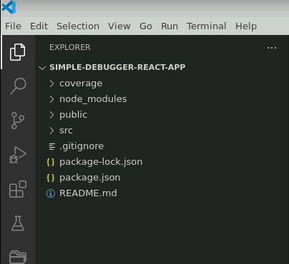

1. Open the **package.json** file and view the external dependencies

**Step 2: Create user-defined components: GitHubUser.js and Posts.js**

1. Create a user-defined component **GitHubUser.js** with the following code:

**import React, { useState, useEffect } from 'react';**

**const GitHubUser = () => {**

**const [user, setUser] = useState(null);**

**const [loading, setLoading] = useState(true);**

**useEffect(() => {**

**const fetchUser = async () => {**

**try {**

**const response = await fetch('https://api.github.com/users/octocat');**

**const userData = await response.json();**

**setUser(userData);**

**setLoading(false);**

**} catch (error) {**

**console.error('Error fetching user:', error);**

**setLoading(false);**

**}**

**};**

**fetchUser();**

**}, []);**

**if (loading) {**

**return <div>Loading...</div>;**

**}**

**if (!user) {**

**return <div>User not found</div>;**

**}**

**return (**

**<div>**

**<h1>{user.login}</h1>**

**<img src={user.avatar_url} alt={user.login} style={{ width: '100px', height: '100px' }} />**

**<p>Followers: {user.followers}</p>**

**</div>**

**);**

**};**

**export default GitHubUser;**

**Note**: **GitHubUser.js** file is responsible for interacting with the default GitHub account details on the current machine with your GitHub follower details. This API is consumed using the fetch() JavaScript function. You also have the option to use Axios third-party modules.

1. Create a **Posts.js** file that is responsible for calling fake REST API to consume the fake post details using fetch() functions with the following code:

**import React, { useState, useEffect } from 'react';**

**const Posts = () => {**

**const [posts, setPosts] = useState([]);**

**const [loading, setLoading] = useState(true);**

**const [error, setError] = useState(null);**

**useEffect(() => {**

**const fetchPosts = async () => {**

**try {**

**const response = await fetch('https://jsonplaceholder.typicode.com/posts');**

**//debugger;**

**if (!response.ok) {**

**throw new Error('Network response was not ok');**

**}**

**const data = await response.json();**

**setPosts(data);**

**setLoading(false);**

**} catch (error) {**

**setError(error.message);**

**setLoading(false);**

**}**

**};**

**fetchPosts();**

**}, []);**

**if (loading) {**

**return <div>Loading...</div>;**

**}**

**if (error) {**

**return <div>Error: {error}</div>;**

**}**

**return (**

**<div>**

**<h1>Posts</h1>**

**<ul>**

**{posts.map((post) => (**

**<li key={post.id}>**

**<h3>{post.title}</h3>**

**<p>{post.body}</p>**

**</li>**

**))}**

**</ul>**

**</div>**

**);**

**};**

**export default Posts;**

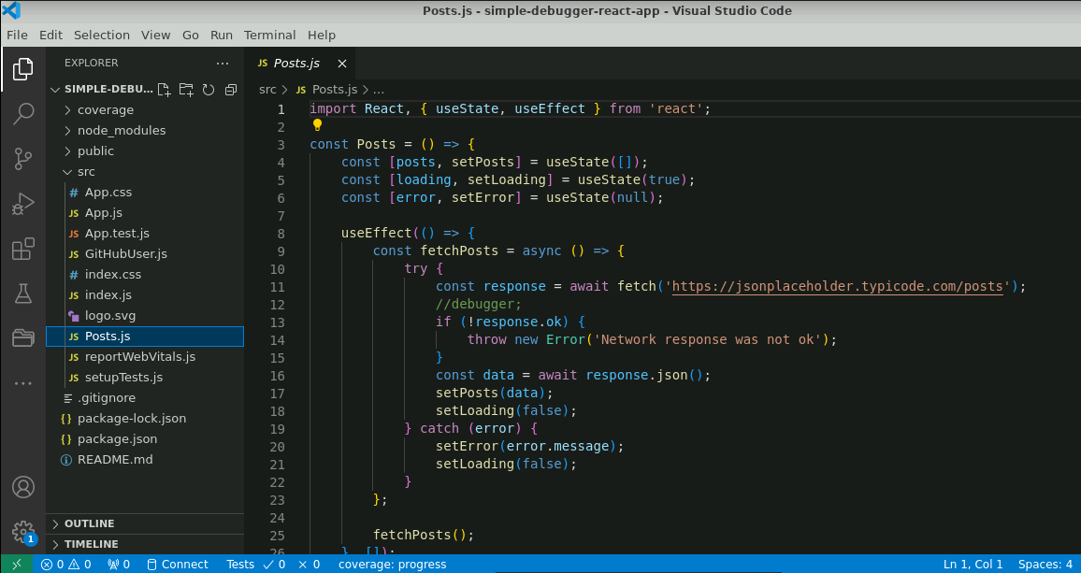

**Step 3:** **Add the components to the App.js file**

1. Add the components **GitHubUser.js** and **Posts.js** in the **App.js** file, as shown in the code below:

**import logo from './logo.svg';**

**import './App.css';**

**import GitHubUser from './GitHubUser';**

**import Posts from './Posts';**

**function App() {**

**return (**

**<div className="App">**

**<GitHubUser></GitHubUser>**

**<hr/>**

**<Posts></Posts>**

**</div>**

**);**

**}**

**export default App;**

**Step 4: Test the application**

1. Run the application using the **npm start** command

1. Open the browser and navigate to **localhost:3000**

1. Search for and click on the **React Developer Tools** extension to download **react-devtools** plugin, as shown in the screenshot below:

1. Click on the **Add to Chrome** button

1. Click on the **Add extension** button and then restart the browser

1. Restart the application with the **npm start** command

1. Open the debugger option in the Chrome browser using **ctrl + shift + I**,then click on **Components** as shown below:

1. On the **Components** tab, click on the **GitHubUser** to check the component details:

1. Click on the **Posts** to check the component details:

1. Open the source code of **GitHubUser.js** or **Posts.js** and use the JavaScript **debugger** keyword to set a breakpoint, as shown below:

1. Check and debug the application in the browser window as shown below:

**Note:** Click on the **debugger** and check the code in the browser to debug.

With this, you have successfully created a simple React application that consumes a REST API and debugged it with React developer tools in the browser using breakpoints.